International Program Committee
President: Prof Susumu TACHI
Austria | Prof P. Kopacek
Belgium | Prof V.Legat  Prof D.Lefeber
China | Dr Qiang Huan
Czech Rep | Prof J.Volf
France | Prof JG Fontaine
Finland | Dr A.Pusa  Prof R.Tuokko
Germany | Prof K.Berns
Greece | Dr J. Galatas
Hungary | Prof B.Kiss
India | Dr K.K.Bhutani
Italy | Prof G.Muscato
Japan | Prof S. Tachi  Prof M.Inami
Korea | Prof Mun Sam Kim
Netherlands | Dr A.van Riel
Poland | Prof A.Maslowski
Portugal | Prof l.Marques
Russia | Prof V.Gradetsky
Spain | Prof M.Armada
Slovakia | Dr Ing. Andrej Babinec .
United Kingdom | ¨Prof KTV Grattan  Prof G.Virk  Dr O.Tokhi
USA | Dr Z.Taqvi

SPONSORING and CO-SPONSORING SOCIETIES and INSTITUTIONS



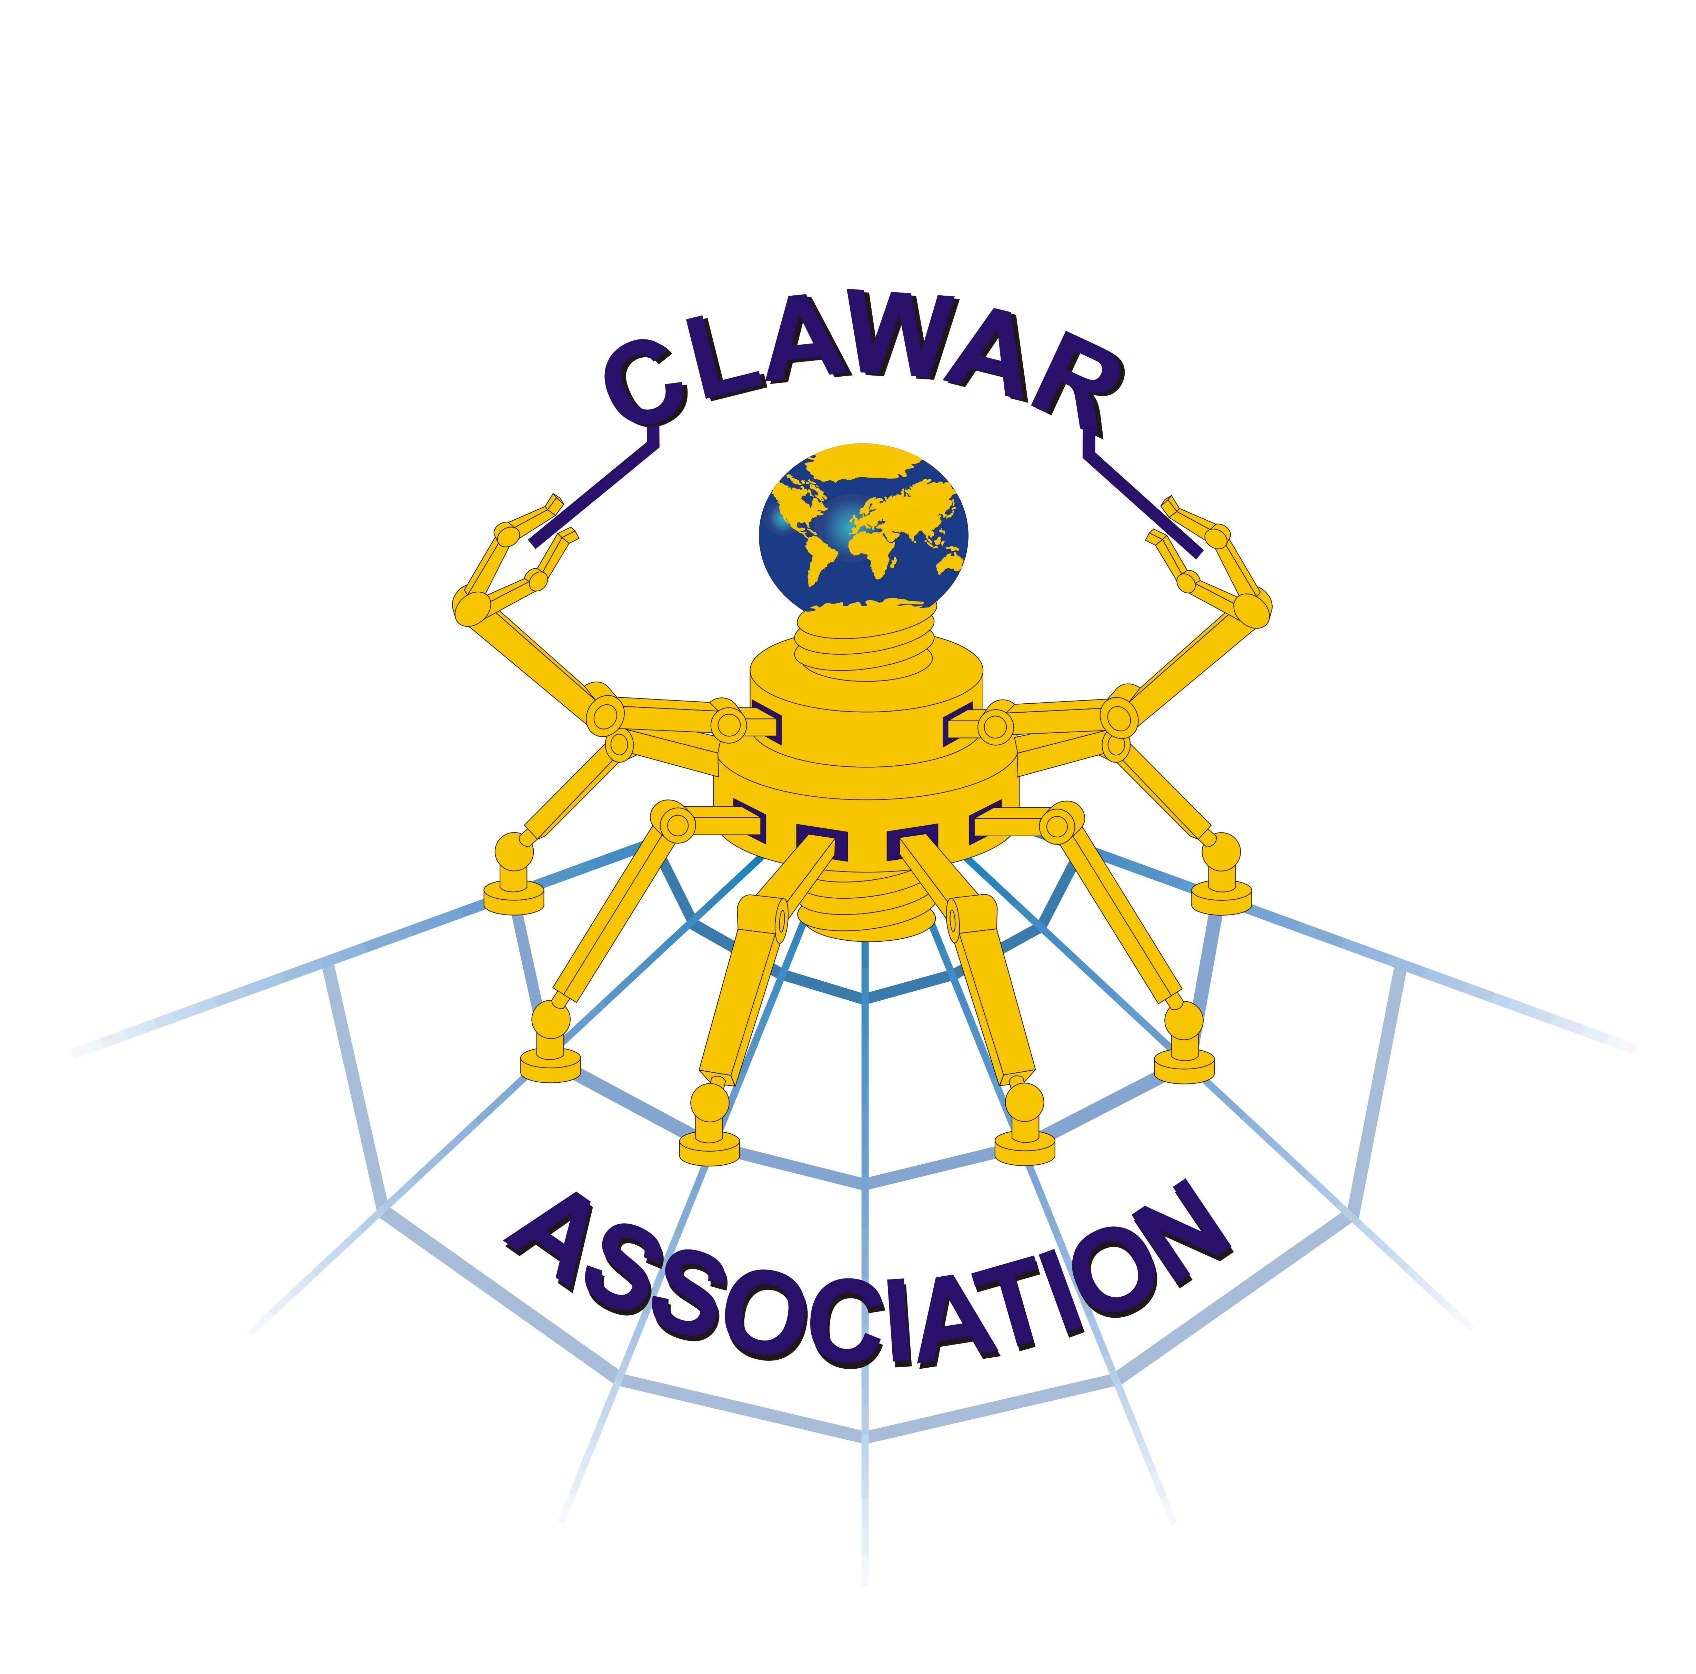
www.clawar.org

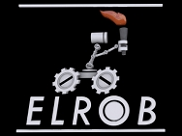
European Land Robots trials
www.elrob.org
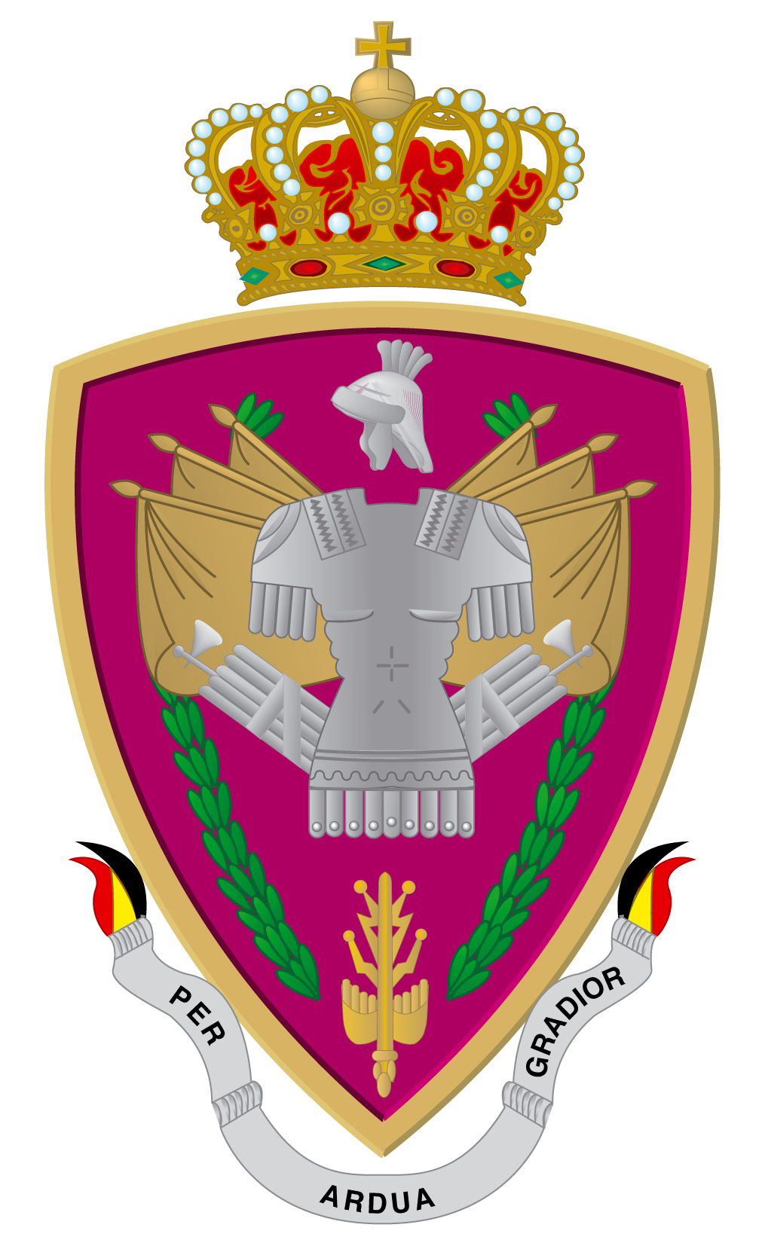
Royal Higher Institute for Defence
www.irsd.be

Time schedule

The contribution should focus on theories, principles and developments which have been explicitly developed for the mechatronics, robotics systems in particular, multi-agent systems and industrial or environmental applications, including the use of virtual tools.
*LATE abstract is allowed (approximately 500 words in English): the publication could be limited to the Abstract proceedings

Yvan.baudoin@ici-belgium.be
frank.schneider@fkie.fraunhofer.de

- Abstract LATE submission*:July,31, 2018
- Receipt of camera-ready
papers/digital papers: Aug 15, 2018

Local Organization Committee

Workshop inquiries to:
ISMCR’2018
International CBRNE Institute
rue de sart-Dames-Avelines, 8A
B6210 Les Bons Villers
Tel: +32 71820840
info@ici-belgium.be
Fax: Homepage
www.ici-belgium.be

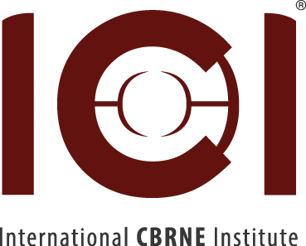

ISMCR 2018
21th International Symposium on Measurement and Control in Robotics
26-27 September 2018 – International CBRNE Institute, MONS, Belgium
ROBOTICS FOR THE CHANGING WORLD

www.imeko.org – TC 17

The 21th International Symposium on Measurement and Control in Robotics (ISMCR-2018) follows the very successful 20th ISMCR’20 held at Bangalore (India) and it is aiming to gather high quality original contributions in the robotic field and associated measurements with the final goal of assessing the most recent developments in this utmost domain of science and technology.
The Symposium scope covers a broad spectrum ranging from advanced conceptual and virtual design and methodology, sensors, actuators, instrumentation, and real-time control algorithms to innovative robotics , mobile (ground/aerial/undersea) robotics and multi-agent-robotic applications.
Fundamentals for Robotics and Mechatronics is considered as a major topic where people from different specialities will contribute to provide a full picture of the state of the art in this area. The key words you will use are essential to organize the different sessions for this conference..

Scope and Topics
Robotics and Automation Techniques: virtual tools
Mobile Robotics: locomotion, actuation, command and control
Outdoor applications (Environmental surveillance, Risky Environments, Rescue, Agriculture, Construction, Space…) . Indoor Applications (Education, Entertainment, Medical assistance, Industry…)
Multi-Agent robotic systems
Sensor systems (CBRNE in particular)
Signal Processing and data-fusion
Participation

 | Before July 31 | After July 31
Participants ELROB | (fees ELROB) | (fees ELROB)
Authors and sponsoring members | 250€ | 300 €
Others | 300 € | 350 €
Accompanying | 150€ | 200€
Students | 30 €/day | 50 €/day
Exhibitors | 300 €/day | 300 €/day

The fees include the lunches, get together dinner, social events and proceedings

General Chairman
Prof em Yvan Baudoin (ICI/RMA)

Program Co-chairs

Prof em. S. Tachi (IMEKO TC17)
Prof G.S.Virk (CLAWAR)
Prof .P. Dehombreux (FPMs)
Dr Ir Schneider (ELROB)
Prof L.Van Biesen (BEMEKO)

The symposium will be conducted in parallel with the Robotics Competition ELROB (www.elrob.org)
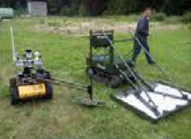

National Scientific Committee

Prof O. Brüls (university of Liège)
Prof D. Lefeber (Vrije Universiteit Brussel)
Prof V.Legat (Université catholique de Louvain)
Prof J.De Schutter (Katholieke Universiteit Leuven)
Prof O.Verlinden (Faculté Polytechnique de Mons)
Prof L.Van Biesen (Vrije Universiteit Brussel)

National Organising Committee

Prof Y.Baudoin (RMA- ICI)
Prof V.Legat (UCL)
Dr Ir G.De Cubber (RMA)
Prof P.Dehombreux (FPMs)
Wildermuth, Dennis (FKIE-Fraunhofer – ELROB)
Dr Ir Schneider (ELROB)
Ir Bernard Sterpin (IRSD, RHID)

